Appendix 1: Work Placement Guide  Business and Management Definitive Document | 

Work Placement Guide
A guide for employers and students.

Business Management Group

Contents

Contents 194
Student Guide to Work Placement 195
A. Work Placement – Quick Guide 195
1. What is work placement? 195
1.1. Work placement has many benefits for students. 195
1.2. Work placement has many benefits for employers. 195
1.3. How does work placement operate? 195
1.4. Student support to find a suitable opportunity. 196
1.5. Student support at work 197
1.6. Quality Assurance 197
1.7. Voluntary Work 197
2. Which subjects can I study at work? 197
3. Four stages to finding work placement. 198
3.1. Stage One - Finding a suitable opportunity 198
3.2. Stage Two - Identifying a suitable potential organisation 198
3.3. Stage Three - Contacting organisations 199
3.4. Stage Four - A successful interview 199
4. Employer organisation checklist (terms and conditions) 200
B. Work Placement Assignment – Personal Development Diary (PDP) 202
1. Example of a diary entry. 203
C. Placement Learning & Work-Based Learning Agreement 205
D. Placement Learning – Employer Feedback Form 208

Student Guide to Work Placement

Work Placement – Quick Guide
- Work placements usually last for twelve working weeks.
- They usually begin in February every year.
- Students are employed and earn wages. We recommend £5 - £6 per hour. Legally, placement students should earn at least the minimum wage (That’s £3.60 for 18-21 year olds, £4.20 for anyone over 22 years old)
- Students attend College to study one day every week (unless advised otherwise).
- Students complete a Personal Development Planning (PDP) assignment whilst at work.
- Terms and conditions apply.

What is work placement?

Work placement has many benefits for students.
- You get the opportunity to put the academic knowledge and skills learned on your degree into practice.
- It can be cited on your curriculum vitae and may help you stand out from the crowd when you begin your career.
- You may get a better job when you graduate.
- You earn extra income from paid work placement.
- You can test out a career option.
- Improve your Personal Development Planning (PDP) skills.
- You feel more confident working with others in teams and groups.
- You develop key employability skills.
- You bridge your own gap between College and the working world.
- You may gain access or develop ideas for your Final Year Project (FYP).
- You’ll make new friends and contacts.

Work placement has many benefits for employers.
- Students will have completed half of their business degree and will have new skills to use in you business
- Students can focus on a single project that other members of staff can not afford to spend time on.
- When the project is complete, the student returns to college. There is no redeployment.
- Students can cover for a member of staff taking paternity or maternity leave.
- You work placement student can cover for long-term illness.
- Students have a range of skills including marketing, Human Resource Management, IT, accounting and finance, business research and communications.

How does work placement operate?
Single Honours Business Management and Business Management Combined Honours students may undertake work placement as part of their second year studies. It normally begins in week one of semester two. You can complete modules in the workplace that count towards your degree. We recommend that you complete two modules at work, and two modules in the normal way at College.
Each module will require a minimum of five weeks in the workplace. A typical WBL student taking two modules through work placement will do the following:
- Take an induction to WBL on campus before their first week. Students will be made aware of their responsibilities:
- As a representative of King Alfred’s College
- Towards the placement organisation and its customers, and employees
- For managing their own learning and relationships
- For recording their own progress and achievements
- For alerting their placement organisation and King Alfred’s of any problems.
- Support during your placement
- Our students will also be made aware of their rights to a safe placement and treatment in accordance with applicable legislation.
- Study two six-week spells back-to-back in the workplace.
- Present a summary of their experiences to staff, employers and other WBL students on campus when their placement has ended.
Students may extend their time with an organisation depending on the needs of the employer and the terms and conditions of the work placement. The opportunity exists to study up to four modules at work, but only where the employer is willing to provide opportunities for the learning outcomes of all modules to be achieved.
This is paid work. You will be an employee of the organisation.
You need to complete a Personal Development Plan (PDP) whilst in work. The outcomes of your module(s) and/or any personal or negotiated objectives will need to appear in your PDP. The completed version should be handed in at the end of the work placement. Please refer to the assignment document and module descriptions for specific details. All students will be given the opportunity to complete the City and Guilds Personal Development Planning Award (PDP). Students are responsible for paying their own registration fee of around £30.00 for this award.

Student support to find a suitable opportunity.
The Business Management Group will not provide any automatic WBL placements. It is the responsibility of students to find a suitable placement opportunity of their own. The Business Management Group will support your search. You will be offered the opportunity to attend three one hour workshops during March, April and June. You will be given coaching/briefings on:
- What is work placement?
- The four stages of finding work placement.
- Employer organisation checklist
One-to-one support is available via e-mail or pre-arranged tutorials with the work placement tutor between March and October. Such meetings could discuss progress on finding a suitable opportunity, contacting employers on the student’s behalf, and so on. Students that do not have a confirmed work placement opportunity by the end of October should study for the College-based modules. This is the final deadline.

Student support at work
Once a suitable work placement opportunity is confirmed, the work placement tutor will make contact with the organisation. An outline learning contract will be drawn up in negotiation with the employer, the student and the tutor. The outline learning contract will contain module outcomes specific to the WBL modules selected and will specify strategies for achieving them at work. Other personal and professional objectives may also be included. The learning contract will form one of the key foundations of the PDP assignment. The PDP will be reviewed and supported during the work placement period, with most support occurring early on. The tutor and student will meet at least three times.
You should have a line manager or mentor in your place of work. He or she will be responsible for you whilst at work. You must give your line manager a copy of our ‘Employer Guide,’ and discuss the employer organisation checklist.

Quality Assurance
All placements will be monitored and evaluated and will feed directly into King Alfred’s quality assurance procedure.
- Informal feedback will be taken from students, placement organisations and tutors before, throughout and at the end of the placement.
- Formal written feedback will be taken from students, placement organisations and tutors at the end of the programme using written feedback sheets (included).
- A module evaluation report will be written by the placement tutor and will form part of the Business Management group’s Annual Monitoring Report.

Voluntary Work
Your may also undertake voluntary work as an alternative to work placement. This is unpaid work. You may already be doing such work and may receive credit for it. The four stages for finding work experience will provide a useful structure for you. You will have opportunity to complete City and Guilds Personal Development Planning Award (subject to a registration fee). Please contact your tutor for details.

Which subjects can I study at work?
The range of subjects that can be studied includes:
- eMarketing e.g. working on web sites
- Accounting and finance e.g. working with an accounting firm
- Human Resource Management e.g. working on employee development or resourcing
- Business Research e.g. conducting some marketing research
- IT e.g. working on databases or Customer Relationship Management (CRM)
- And many more to suit you or your business. Take a look at some case studies on www.wkac.ac.uk/business/we/

Four stages to finding work placement.

Stage One - Finding a suitable opportunity
- Consider what kind of career you wish to follow e.g. accounting, marketing, business information technology, human resource management, business research, and so on.
- Look at the second year semester two WBL modules and select the most suitable. Early choices can be substituted once a suitable organisation had agreed to employ you.
- If you do not know what you what to do at this point, try something that involves your interests e.g. helping people, working with teams, use of information technology, and so on. Everyone will be different.
- Think about other drivers such as:
- How much do I need to earn each week?
- How will I balance the time between work, study and my social life?
- Where do I want to do it? It could be close to ‘home’ or near to Winchester.
- How will I get to work? Do I need a car?
- Do I want to be office based?
- How closely does any opportunity relate to my degree discipline or choice of optional modules?

Stage Two - Identifying a suitable potential organisation
- Most companies have at least one project that needs the attention of a single employee but cannot free anyone up to see it to completion. Managers are often busy people and will not have had the chance to plan ahead, and so a work placement student can be an ideal solution.
- Sometimes organisations will need the kind of skills and knowledge that you have studied on your degree so far.
- As a work placement student you can undertake jobs that might not otherwise be done within the time and resource limits imposed upon companies.
- Sometimes other employees will have taken leave for maternity/paternity, or other personal reasons.
- An employer may wish to employ you once you have graduated and could use work placement as an opportunity for you to prove your worth.
You can begin to identify suitable organisations by:
- Look in the recruitment pages of the local newspapers to see who is recruiting and in which areas. This is also a useful source of contact information e.g. personnel e-mail addresses.
- Speak to family and friends to inform them that you are looking for a suitable employer. This word-of-mouth strategy has a high success rate so please use it.
- Sometimes employers will approach the College directly. Any opportunities will be promoted on Business Management notice boards.
- Going to our Careers Service. Organisations that offer permanent jobs to students on graduation, will often be interested in offering work placment opportunities.
- There are a number of useful websites including:
- www.work-experience.org
- www.topjobs.ac.uk
- www.jobsunlimited.co.uk
- www.prospects.ac.uk
- www.milkround.co.uk
- www.wcn.co.uk

Stage Three - Contacting organisations
It is important to find out as much as possible about the company that you are contacting such as:
- What business are they in?
- What is the name of their CEO or Managing Director?
- What have they been involved in recently? E.g. new products, public relations, etc.
You should prepare a ‘targeted’ curriculum vitae and a ‘focused’ covering letter. Do not reproduce the same letter and simply change names and addresses. Avoid cover all phrases such as ‘an organisation like yours’. Companies receive many approaches from students for work placement so make yours the one that they respond to positively. Get someone else to proof read the documents and use good quality paper and envelopes.
Make sure that you:
- Explain why you are interested in their organisation.
- Tell them why you want work placement.
- Tell them the business and personal skills that you have to offer them.
- What will you do for them if you are taken on?
- Describe the relevance of your course and any other experience that you may have.
- Include any ‘relevant’ hobbies (going to the cinema is not relevant to a job working for The County Council’s Policy Unit), voluntary work or interests.
Advice on how to prepare a CV and covering letter can be had from our Careers Advisory Service. Here are some websites to help you with these important documents. Remember KISS: Keep It Short and Simple!
- www.alec.co.uk/cvtips/writstcv.htm
- www.soon.org.uk/cvpage.htm
- www.bradleycvs.co.uk/cvservice/examcv.htm
- www.careers.ucr.edu/Students/Graduates/CV/index.html

Stage Four - A successful interview
Prepare for the interview by viewing it from the manager’s perspective:

- Why should the company take you on?
- Can they spare the time to supervise a student? (think of an
example where you had to work on your own)
- Why did you choose your particular course of study?
- What are your strengths and weaknesses? (e.g. what you are good at or do you enjoy?)
- How much do you know about this sector of work?
- Have you successfully completed a project before?
- How would you cope with difficult situations? Give an example.
Present yourself on time and dressed appropriately for the job to make a good impression. Show a positive attitude. Show that you are genuinely interested in the company by thinking through ideas for your work them.

Employer organisation checklist (terms and conditions)
Congratulations! You have achieved your goal. Before you begin the work placement you need to confirm terms and conditions with your employer by checking the following:
- All placements must be suitable for a second year undergraduate business management student. That means that learning outcomes of modules are achievable. The placement tutor will clarify them with employing organisations and students in the form of an outline learning contract. Has this been done?
- Confirm that the organisation has the ‘Employer’s Guide.’ Has this been done?
- Start date will be week one of semester two of your second year. This will vary but is normally late in January or early in February.
- Start/finish times of your working days. Most students will study two modules from four in the workplace. That would mean spending a day every week at College (Single Honours), or two half days (Combined Honours).
- What is your holiday entitlement and how do you arrange it?
- What are the lunch arrangements? Is there a restaurant or do you need to take sandwiches?
- Dress code. How do you dress for work?
- Who do you report to? Find out where to go on your first day. Who is your direct line manager or mentor?
- Wages and Salaries - Method of payment i.e. weekly/monthly, check or bank transfer.
- You should earn no less than the minimum wage. Workers aged 22 or over must be paid at least £4.20 per hour (October 2002). Workers aged 18-21 must be paid at least £3.60 per hour (October 2002).
- When you finish your employment you should collect your P45 form. This states how much National Insurance has been paid and is therefore evidence of your contributions and that your employer has paid.
- Do you have to pay tax or national insurance? The amount you have to earn before paying tax is approximately £4,000 p.a. You have to start paying National Insurance contributions once you start earning more than £66.00 per week.
- Clarify the aims and outcomes for the work placement. Ask for clear instructions about your project, preferably in writing. The project should cover all of the outcomes for your selected module(s). Aims and outcomes can be found in the module descriptions.
- Clarify your employer’s expectations. Your employer should offer you an induction.
- Clarify your own expectations. Explain about your assignment(s) and the need to complete it during your time with the organisation. Explain your own objectives from the outset.
- Absence procedure - Check the name of the person you need to notify if you are absent for any reason, e.g. illness. Please let you tutor know of your illness.
- Health & Safety Matters – Fire and Emergency Procedures - Ask for general instructions in the event of fire/emergency evacuation. Check for:
- location of any alarm call points/fire marshal
- location and use of fire extinguishers
- location of emergency exists and assembly point
- Name/location of person responsible for providing First Aid
- Health & Safety Policy and Procedures
- You should be given a general explanation by your manager/supervisor about the company/organisation’s policy.
- Ask them to outline duties you will be allowed to undertake and any restrictions/precautions, e.g. supervision, protective equipment needed.
- Ask to be made aware of any specific hazards and associated procedures.
- Ask if there are any activities which you must not undertake and/or areas/locations which must not be entered.
- Make sure that the company/organisation has Employer’s Liability Insurance.
- Overseas students from non-EEA countries no longer require a work permit to take part-time and vacation work. A number of restrictions will still apply:
- the student must not work more than 20 hours a week
- during term time, except where a work placement is to be undertaken as a necessary part of the course of study as agreed by the education institution
- the student should not pursue a career by filling a permanent or part-time vacancy.
- Further clarification can be obtained from the Home Office.
- Remember to ask about whether the company has an Equal Opportunities Policy as you should be treated like everyone else.
- In the event of any problems occurring you must contact your tutor or any other member of the Business Management Group without delay. Complaints will be handled according to The School of Social Sciences Complaints Procedure which is available from our school office.
- King Alfred’s College reserves the right not to accept a work placement opportunity. This is for protection of the student, and of the College’s reputation. Students need to be aware that failure in a work placement could result in a gap in their academic profile, a gap that cannot be redeemed without concentrated study of the taught version of the module(s) affected.
- Work placement is available to all single honours and combined honours Business Management students. Students that enter directly into year two will have missed the preparation for work placement and will not be offered it.

Work Placement Assignment – Personal Development Diary (PDP)
Aim
The purpose of this assignment is to enable and encourage you to reflect upon how applicable the leaning on your degree course has been to your personal development process. The diary will help to illustrate how the learning process has allowed you to develop different attitudes and styles of working over the period of your work placement.
The format that your personal development diary will take is entirely up to you, as long as the specific tasks below are covered. You should take time to settle into your placement, and so it is recommended that you begin about four to five weeks in.
The learning of this module is supported by books, magazines, journals, and other learning resources that you may need to help your personal development. You are strongly encouraged to make use our library.
The assignment should be no longer than 5000 words (including 1000 word reflective statement). It is designed to be reflective, and that means that it may appear unstructured in comparison to reports or essays that you have worked upon. It will be as structured as your individual learning experience.
Specific Tasks
- Write a five hundred word summary of the purpose of your work placement project. You should include the objective(s) of the project.
- Conduct a SWOT analysis of your personal strengths, weaknesses, opportunities and threats as you begin your work experience. Include it in your final submission.
- What do you want to get from your work experience? Why are you putting yourself through it? State two SMART personal objectives at the beginning of your diary.
- Include a curriculum vitae.
- Diary entries should be kept weekly or biweekly, and should be made to record learning following any ‘significant events’ e.g. after visiting a major customer, or if you received praise or punishment for a particular project. Explain what happened. How did you feel? What will you do differently in future? What resources or assistance would you need? Do you need to set in place new action points or objectives? The journal should contain 15 – 20 main entries in the format attached.
- Write a one thousand word report to your employer. The report should reflect on your stated objective(s) and explain how it was achieved. You should use a formal report format.
- Finally, near the end of your work experience period, write a 1000 word reflective statement to summarise your learning. How has the work experience helped your personal development? How can you plan for your future development?

What are the aims/outcomes of your placement learning?
What is the hand in date for the Personal Development Plan (PDP)?

(aims and outcomes can be found in the relevant module description and should form part of your learning agreement)

Example of a diary entry.
Diary Entry: 11 Date: 27th February 2003
Learning Experience:
Summary of Weeks 21 and 22
What happened?
I was invited to give a presentation to a group of customers. It lasted for about twenty minutes and included time for questions. I had prepare the presentation with the assistance of Mr Jones. It included bullet points and graphics relating to the launch of our new Aquabubble range.
I was initially very nervous. I hadn’t rehearsed the presentation. When I began, I stumbled over my words a little but the audience were very friendly and soon the presentation became more like a conversation. I was especially please when I found out that one of the customers had placed an order for a pallet of Aquabubble based upon the information from my presentation.
Next time I present I’ll make sure that that I rehearse it first, and will ask one of my work mates to offer feedback. I would feel confident to prepare and present in the future.
The presentation helped me to reach my second objective relating to improving the professionalism of my business communication.
I continued to work on my HRM project. I’m still waiting for information from personnel.
Conclusions
I found the presentation challenging and demanding. I look forward to doing a similar project in the future.
I must put more time into my HRM project.
Actions
- Rehearse presentations in the future
- Gain feedback from work mates on presentations
- Contact personnel to find out where information is for my HRM project.
- Look for opportunities to use Aquabubble as a case study for my FYP

Approximately 250 word per entry.

Placement Learning & Work-Based Learning Agreement
King Alfred’s College - Business Management Group

Student Name
Student Contact Details
Term-Time Address
E-mail
Home Telephone | Mobile Telephone

Employer Contact Details
Name of Employing Organisation
Address
Manager/mentor responsible for student
E-Mail
Work Telephone
Lecturer(s) responsible for co-ordinating placement learning/WBL
E-mail
Work Telephone
Module Details
Module Code
Module Name
Aims/Learning Outcomes – by the end of this placement learning/WBL I will be able to:

Details of the project or tasks. How will outcomes be achieved at work?
Activities needed to complete outcomes that cannot be achieved at work (e.g. tutorials, distance learning, lectures).
What resources will be needed?
What is the timing or duration of this placement learning/WBL?
Dates for review
1.
2.
3.
4.

Signatures
Student
Name
Date
Signature
Employer
Name
Date
Signature
Tutor
Name
Date
Signature

Placement Learning – Employer Feedback Form
King Alfred’s College – Business Management Group

Please offer some feedback on your placement learning/work-based learning student. Feel free to comment on any aspect of his or her work but be aware that the document may be shown to the student. You may wish to comment upon:
- Professionalism
- Time management
- Attitude to work
- Working in teams
- Leadership qualities
- Behaviour in the work place and with customers.

Please comment on the support received from King Alfred’s College.
Manager/mentor responsible for student
Organisation
E-mail
Work Telephone

Further Information

For further information please refer to our work placement website www.wkac.ac.uk/business/we/ or contact:

Tim Friesner
Business Management Group
School Of Social Sciences
King Alfred’s College of Higher Education
Sparkford Road
Winchester
SO22 4NR
(01962) 827245
tim.friesner@wkac.ac.uk
Professor Mike Hart
Business Management Group
School Of Social Sciences
King Alfred’s College of Higher Education
Sparkford Road
Winchester
SO22 4NR
(01962) 827329
mike.hart@wkac.ac.uk

Gill Beck
Group Administrator
Business Management Group
School Of Social Sciences
King Alfred’s College of Higher Education
Sparkford Road
Winchester
SO22 4NR
(01962) 827323
gill.beck@wkac.ac.uk

Appendix 2 Assessment of Learning Outcomes in Work Based Learning [WBL]
Appendix 1 (above) indicates the Principles for Work Placement adopted by the Business Management team. This document is principally designed for those full-time students who are seeking to undertake Work Experience as part of their undergraduate programme and wish to claim credit against one or more modules that they would normally have studied.
For students attending a Foundation Degree already in full time work (apart from their attendance in college), such principles will need some adaptation. It is suggested that the following criteria be applied to the Assessment of WBL (Work-Based Learning) modules studied as part of this Foundation degree.

1. Work submitted should demonstrate that:
(a) the learning outcomes of the module are substantially covered
(b) A Personal Learning Log will form part of the assignment in which the student
gives a reflective account of progress in attaining their specified objectives and
an analysis of their own learning styles and achievements

(c) The assignment will require an analysis of the methodologies deployed in the
collection and analysis of data which has informed the analysis.

2. Work shall marked (and moderated) solely by College Staff and made available to External Examiners following normal procedures

3. Roles of employers in the WBL process can be described as:

- to facilitate and support student efforts in their chosen field of study

- to advise, encourage and, if necessary, warn of difficulties, in a mentoring
capacity
- assist the student to undertake project material which would be not only
organisationally important but would also form of a student portfolio

- allow work-based materials to be adduced as evidence (subject to normal
safeguards of confidentiality, anonymity of third parties etc.)

- offer a judgement on the quality of the student project work which can be used
to inform the judgements of the marking (and moderating) tutors

- to give feedback to the college either as individual comments upon the work of a
student or as part of a more general employers’ forum on the quality of the
student’s learning experiences
- Indicate to the college emergent areas which it is felt the college could address
in any review of the curriculum.
- The college undertakes to supply employers with results of a tabular nature
indicating the performances of the student group as a whole. Individual
students may wish to indicate to line managers the results they have achieved
for modules undertaken. However, it shall be understood that such data is
normally regarded as confidential (between students and college staff ) and not
automatically subject to release to third parties.
Appendix 3 Use of the VLE as a Learning Experience

The College’s own VLE (Virtual Learning Environment) enables both tutors and students to:

- access downloaded material (typically lectures in the form of PowerPoint
presentations)

- share valuable resources (articles, links to websites)

- maintain contact with each other individually and on a group basis

- maintain bulletin-board type discussions

- sample other modules (with permission) in order to make informed
choices

- download materials in anticipation of a lecture to make more interactive
and productive seminar sessions with tutors

When students are geographically dispersed and particularly for mature students who may have sudden unanticipated work commitments, the deployment of a VLE can help to make study time much more productive and vibrant, assuming access from both home and, on occasions, the work place.

The College’s own VLE will be particularly useful to Foundation Level students who only attend college for one half day per week. It assists in keeping learning opportunities vibrant and relevant in periods of time when they are not attending college. In particular, it is anticipated that the VLE will prove to be of particular relevance to students who intend to take the WBL [Work Based Learning] modules in the June to September periods of the college year.

At the same time, it needs to be recognised that occasionally students have difficulties in accessing particular parts of the College’s VLE if they have to operate from within a firewall policy which inhibits the use of bulletin type facilities. Newly enrolled students or those making enquiries about the course may not be able to access the VLE until full registration procedures have taken place. The course team have put some of the critical material, including bulletin boards, on a server with its own domain name (www.psim.co.uk) which works in tandem with the VLE, providing a backup in the case of downtime and overcoming some of the difficulties of access referred to above. Present students have commented very favourably on the ease of use of these facilities and have grown to use both the specialised websites and the college’s own VLE with equal facility.

Apart from the VLE, members of the Business Management team have developed specialised websites, aimed to appeal to students on a far wider basis than those studying a single module. Examples include:

Loykie Lomine’s site on Qualitative Research Methods
http://www.quals-for-business.com

Tim Friesner’s (recently ex-KAC) website on Work Based Learning
http://www.wkac.ac.uk/business/we/

Mike Hart’s site giving practical advice on final year projects
http://final-year-projects.com

David Rush’s site on What is Usable and Effective Web Design?
http://www.wkac.ac.uk/designproject/about/about.htm

These are all referenced from the Business Management’s group own extensive website:

http://www.wkac.ac.uk/bm

which itself gives students access to a range of documents, group policies and general information pertaining to all business students.
Appendix 4: Mike Hart’s Tutorials

General Tutorials
Help with Essays and Assignments
How to write a bad assignment
Quick Guide to Harvard Referencing
Harvard Referencing-Frequently Asked Questions
How to write a successful Final Year Project - a practical guide
Examination Hints
Plagiarism
Using Academic Journals- Guidance written by Loykie Lominé
Forms
Essay and Assignment Checklist
Oral Presentation: Assessment Sheet
Declaration of Academic Integrity
Final Year Project Supervision Meeting Record
Course Specific Materials
MICROSTATS [Public domain version]
EZESTATS [Save self-extracting ZIPped file and then extract under DOS with the command EZE_ZIP. Type EZE to run]
Quality Management and Customer Care - Frequently Asked Questions
Useful Links
Link to Mike Hart's Incredibly Useful Websites
[URL] http://kac-tutor.co.uk

Appendix 5: Mike Hart’s Notice Board

Mike Hart's Tutorials website |  | http://www.kac-tutor.co.uk/
Help with Essays and Assignments |  | http://kac-tutor.co.uk/essays
Plagiarism website |  | http://kac-tutor.co.uk/plagiar
Mike Hart's Incredibly Useful Websites |  | http://www.kac-tutor.co.uk/useful
Lectures: 2003-2004 |  | http://www.kac-tutor.co.uk/lectures
Final Year Projects |  | http://www.final-year-projects.com
Public Services Information Management (PSIM) |  | http://www.hants.gov.uk/psim
PSIM Lectures and Materials |  | http://www.psim.co.uk
Business Management with Public Service Management |  | http://www.psm.ukhe.com
Mike Hart's Recent Papers |  | http://www.mikehart-papers.co.uk
KAC Business Management Recent Papers |  | http://www.business-kac.co.uk/recent.html

[URL] http://notice.such.info
Top of Form
Bottom of Form

Top of Form
Bottom of Form

mch

Appendix 6: PSIM Lectures and Materials

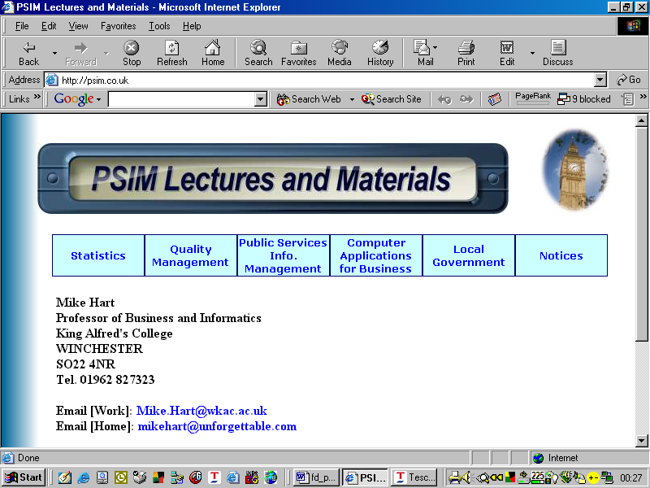

[URL] http://psim.co.uk

Appendix 7: PSIM Notice Board (Bulletin Boards)

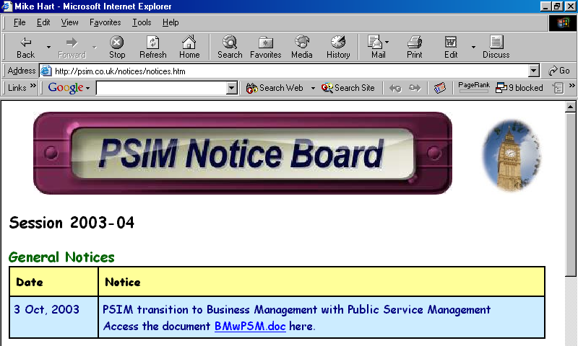

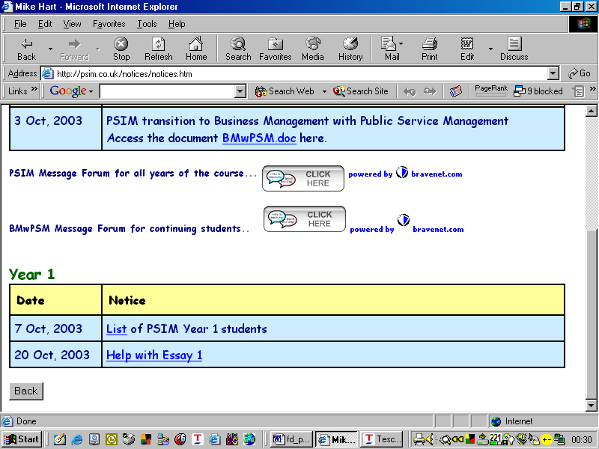

[URL] http://psim.co.uk/notices/notices.htm

mch

Appendix 8: Programme Approval/Re-Approval (Resources) Form

PR46 Page 1
PR46 Page 2
PR46 Page 3
PR46 Page 4
PR46 Page 5
PR46 Page 6
PR46 Page 7
PR46 Page 8
PR46 Page 9

