EZESTATS: Instructions for
Download – Unzipping - Running

1. Access the webpage: http://better.ws/statistics and click on EZESTATS

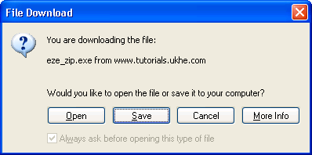

2. Select Save giving a folder or a drive e.g. A: or \MyDocuments

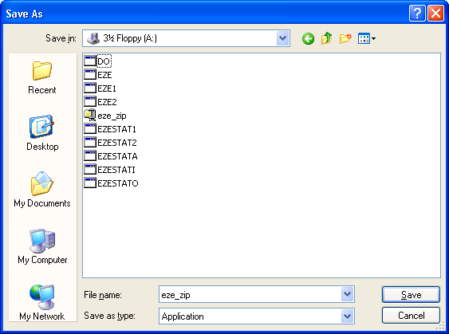

3. Then Close the window and the website.

4. Start…Run and then type in command [OK]

. 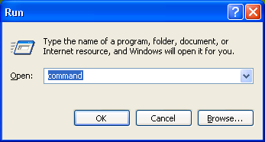

5. A DOS box opens…

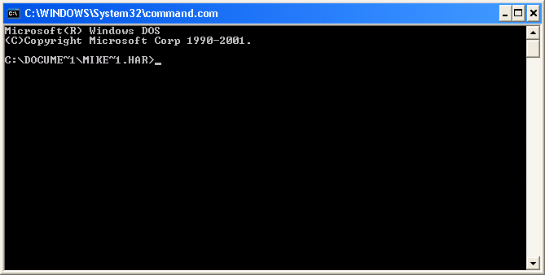

6. Right click on the blue border to get Properties and then:

select Options…Full Screen…[OK] Apply properties to current window only [OK]

7. Use Dos commands to get to the folder (e.g. A:)

8. Run self-extracting ZIPped file by typing in EZE_ZIP and then press [ENTER]. You
will need to select a folder and/or a drive for the unzipped files.

9. You may need to retrace steps from 4, 5 and 6 above to open a DOX Box, maximise
its window and navigate to your drive or folder again.

10. Run EZESTAT suite by typing in EZE and then press [ENTER]

11. Windows may make the introductory screens run in a minimised approach and with
garbled characters but the main programs will run with no difficulty

12. Exit the DOS box and return to Windows by typing EXIT [ENTER]

