PERSONAL DEVELOPMENT PLANNING

By three methods we may learn wisdom: first, by reflection, which is noblest; second, by imitation, which is easiest; and third by experience, which is the bitterest. (Confucius)

INTRODUCTION
The term personal development planning (PDP) is being used to describe the means by which students can monitor, build and reflect upon their personal development. Higher education already employs a variety of strategies to encourage students to reflect upon and evaluate their own learning experiences and plan for their own development. A variety of terms are used to describe this process of reviewing and recording learning and achievement, and action planning e.g. Personal Profiling, Personal and Academic Records, Personal (Academic) Development Plans, Progress Files, Learning Portfolios and Diaries to name but a few. Many of these terms emphasise that the records are a product of process. The term personal development planning is used in order to emphasise that this is an active learning process undertaken by individuals for themselves.

The primary objective for personal development planning is to improve the capacity of individuals to understand what and how they are learning and to review, plan and take responsibility for their own learning. It is intended to help students:
- Become more effective, independent and confident self-directed students
- Understand how they are learning and relate their learning to a wider context
- Improve their general skills for study and career management
- Articulate their personal goals and evaluate progress towards achievement
- Encourage a positive attitude to learning throughout life

The ideas behind these concepts mean that PDP is:
- A structured approach that is integral to higher level learning
- Concerned with learning in an holistic sense
- Carried out by the individual with support and guidance; the latter perhaps decreasing as personal capability is developed so it becomes self sustaining
- A process that involves self reflection, creation of personal records, monitoring of progress towards the achievement of personal objectives

The reflective and planning skills on which the idea of PDP is based, are integral to knowing how to learn in different contexts and for the ability to transfer learning.

PDP results in two main outcomes. The first is enhanced self-awareness of strengths and weaknesses and directions for change. The process crucially relates to the personal development as a whole person. The second outcome is a record of learning experiences and achievement, personal reflections and plans for self improvement that will provide a unique resource to each individual.

The potential benefits of PDP to students are many. It will help the student improve their capacity to plan their own academic programmes, be more aware of how they are learning, recognise their own strengths and weaknesses, and identify opportunities for development outside the curriculum. PDP should also ensure the student is better
prepared for the demands of continuing professional development when they enter employment. PDP will assist academic staff by helping students be independent about their learning, creating a mechanism through which career-related skills and capabilities can be recorded, creating a mechanism through which career-related skills and capabilities can be recorded, and by improving their understanding of the development of individual students so more meaningful employment references can be provided on their behalf.

AUDIT OF CURRENT SKILLS AND APTITUDES

The role of Advice Team leader is to lead the Advice Team in providing a service to the public and businesses of Hampshire. This is a front line service for the County Council and provides this contact for Trading Standards and Registration Services. External to the County Council the service provides links to the utility regulators, central government agencies and other enforcement bodies throughout the UK.

The scope of the Service is far reaching with much European legislation having a major impact on the community as a whole. Injunctive action is something that can be undertaken on a Europe wide basis and in practice could mean court action commencing in a European country for consumer detriment suffered in Hampshire. I t could also mean the reverse, court action starting in Hampshire for a European wide issue.

My role of Advice Team Leader is based around five core competencies:
- Working together. Getting the best out of working relationships. Sharing information and ideas, working within teams
- Continuous improvement. Being committed to continuous improvement, recognising the need to develop new ideas, review systems and procedures
- Delivering quality outcomes. Being committed to delivering quality outcomes, responding to customers in a positive way and seeking customer feedback
- Effective use of resources. Making the best and most sustainable use of the time, technology, financial and physical resources available
- Personal commitment. Demonstrating commitment to the Council and its aims. Taking personal responsibility and accountability

Working Together – In fulfilling my role as part of the team I ensure we function efficiently, sharing some responsibilities and supporting staff in their day to day duties as well as taking overall responsibility for the workload of the team. The team prides itself on working well together as part of a high performance team so that all the necessary tasks are completed to a consistently high standard and in a timely manner. The workload has increased by 23% in the last two years with no increase in complaints but a rapid rise in the number of compliments has been received. With over 20,000 enquiries a year this is a large and frequently complex task with constantly changing deadlines and a requirement to be flexible to accommodate the needs of others.

Outside work I am a Parish Councillor and School Governor. This involves making decisions on specific issues but also to take part in the collective decision making process for the good of the parish and school and not just for the individual.

Continuous Improvement – I am committed to the concept of continuous improvement within the Advice Team. ISO 2003, the Community Legal Services Quality Mark, and Investors In People have been awarded on successive occasions. I have helped put together and keep up to date the relevant quality documents to support these awards and ensure the Advice Team continues to provide a quality service by quality advisors for the benefit of the consumers of Hampshire. I am also the person responsible for coordinating the use of the Complaints Database and monitoring the type and level of complaints that are made. This responsibility is for the whole department not just my team.

I have organised and participated in a number of training events for my own staff as well as working in collaboration with all the Citizens Advice Bureau in Hampshire to facilitate a more joined up approach to Advice throughout Hampshire. I have devised a series of Codes for recording the advice given in order to reduce the write up time after each enquiry. These Codes are used by all the team with each enquiry.

Delivering Quality Outcomes – My job means I am committed to delivering a quality service. In order to do that quality advisors are necessary. Training and development of staff is crucial to ensure complaint levels are low, consumers are satisfied with the service, and a satisfactory outcome is obtain each time the service is audited.

Effective Use of Resources – With the advent of the internet, there has been a major shift from paper sources of data to an electronic format where the information is readily available and accessible by many more people at the same time. The internet has transformed the exchange of information and my working day is based around the internet and its information sources. Much of the information I have access to is highly sensitive and subject to the rigid controls of the Data Protection Act 1998 and the Enterprise Act 2002 so I am fully aware of the restrictions they can impose on my working practices when it comes to sharing sensitive information.

Personal Commitment – My current role involves leading a team of seven staff but also to help with the running of the office so incorporates a wider field of staff I am responsible to. I am required to carry out personal development reviews for all my staff and ensure they are adequately prepared for their role. In order for me to do that it is necessary for me to keep up to date with the most recent legal decisions, legislation and opinions. I have developed a training manual for the new advisor to help with their induction and this has been adopted across the South East Trading Standards Service so all new advisors start off with the same core information. I have been involved from its inception with the Consumer Support Network. This is a network of various advice agencies throughout Hampshire who work together to try and provide a seamless approach to advice for the consumer.

I learned to appreciate the interaction between theoretical principles and their practical application in a working environment. This was particularly relevant when I left nursing to start a new career working for Trading Standards after studying for a law degree. As a nurse I was helping people to recover by the practical application of knowledge. As an advisor I am helping consumers to understand some often very complex legal situations and to find a practical solution to their problem. The same principles are used to ensure people understand what the problem is, whether it can be fixed, if so, how will that be done, and the likely outcomes. When people are in situations they do not readily understand it can mean their reactions are not normal. Careful handling and empathy are essential to ensure the consumer actually takes in the message being sent and not the message they would rather receive.

LEARNING STYLES

David Kolb developed his learning style model in 1984 (1). It is based on two lines of axis: our approach to a task – (preferring to do or watch), and our emotional response (preferring to think or feel). The theory sets out these four preferences:
- Doing (active experimentation)
- Watching (reflective observation)
- Feeling (concrete experience)
- Thinking (abstract conceptualisation)
These learning styles characteristics are normally shown as two lines of axis. The east-west axis is how we approach a task, and the north-south axis is our emotional response, or how we think or feel.

The diagrams below illustrate these points. The combination of where our preferences lie on each axis will produce a possible learning type. Knowing what you own learning style is helps learning to be orientated to the preferred style. However, this is not to say that the same learning style should be used every time. It may be better to choose a different method of learning to suit the occasion.

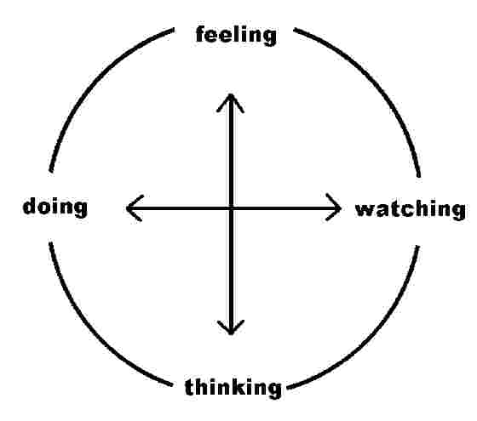
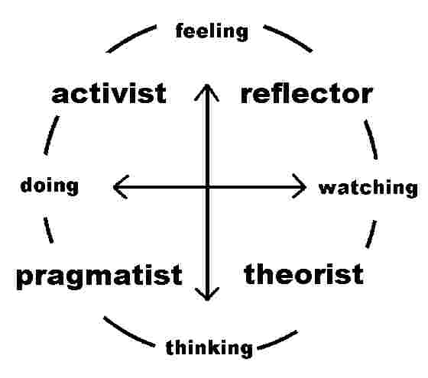

I have completed a Learning Style Indicator and the outcome would suggest I am a Watcher – reflective observation and concrete experience. The full results are attached at appendix 1. (Learning Style Indicator)

Since its inception in 1943, the Myers-Briggs Type Indicator (MBTI) has evolved and many people have taken the test although a test is probably not the best way to describe the MBTI as it is more of an inventory. A test would suggest pass or fail and there are no wrong answers with the MBTI. All answer choices can be equally desired. There are many versions of the MBTI on the internet and so for the purposes of this report I have elected to carry out a mini version of the MBTI to see what my personality type is. ( results attached at appendix 2)

The results would suggest I am an INFJ. In the MBTI classification this suggests I am future-orientated, my work mirrors my integrity, solitude and a chance to catch up is important, and I like to quietly exert my influence. I desire harmony with others and will go to great lengths to avoid conflict. I am able to understand the complexities that exist within people and let my accomplishments do the talking. I am considered to be gentle and do not like violence. The MBTI results also suggest I have a strong love of learning and get along well with teachers and older people. I have a dislike of ‘office politics’ as I would prefer to talk honestly with people rather than play games. I am considered quiet but persistent and determined in my efforts towards my long term goals and like to win cooperation rather than demand it. The more negative aspects of this inventory would suggest that if I do not act assertively I could lose out as others will take advantage.

This very short assessment cannot replace the extremely comprehensive inventory when carried out professionally. However, it does give a rather insightful peek into my personality type and learning styles and has highlighted to me the need to consider the many different learning styles in order to make the most of the opportunities open to me.

CONCLUSION

Considering the different learning styles has never been a major feature of my academic life so I may have lost out on some of my achievements because of this. I have been aware of the existence of different styles but never really considered their importance and how I might use them to my advantage. I have favoured some subjects over others and particular types of assessment easier to deal with than others but until now I have not consciencely thought about why this is so. It is a reflection of this particular report that I am much more aware of the different learning styles and the impact they can have on the outcomes of a course of study. The benefits of this will show in the outcomes of my future academic studies.

REFERENCES

www.qaa.ac.uk
www.nwlink.com/~donclark/leader/leadcom.html#back4
www.businessballs.com/kolblearningstyles.htm
www.uncommon-knowledge.co.uk

APPENDICES

- Learning Style Indicator
- MBTI Inventory questions

