Business and Informatics QAA visit,
19th-22nd February, 2001

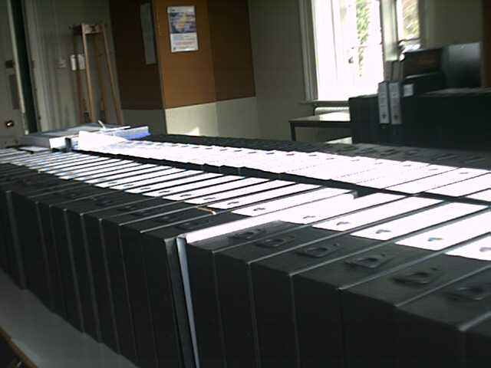

View of the Base Room [MB1] taken just before mid-day on Monday, 19th February, 2001.

The photograph shows approximately one half of the 127 boxes of evidence prepared for the QAA inspection team.

