Start

Auskerry Location  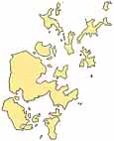 | OS grid reference: HY675165  Names  Norse name: Austrsker  Meaning of name: east skerry  Area and Summit  Area: 85 ha  Area rank (Scottish islands): 152=  Highest elevation: 18 m  Population  Population (2001): 5  Population rank (inhabited Scottish islands): 80= out of 97  Groupings  Island Group: Orkney  Local Authority: Orkney Islands

end

