Free e-learning for the Greater China Region: a cultural analysis of the Marketing Teacher experience.

Tim Friesner
Senior Lecturer in Marketing
Business and Management
University College Chichester
College Lane
Chichester
West Sussex
PO19 6PE
t.friesner@ucc.ac.uk

Mike Hart
Professor of Business and Informatics
Business Management Group
King Alfred’s College
Sparkford Road
Winchester
SO22 4NR
mike.hart@wkac.ac.uk

Abstract

This paper considers the e-learning issues facing a free content website for the Greater China Region. A series of cultural models and frameworks are applied to review the literature relating to the Greater China Region and e-learning. Findings are contrasted with the outcomes of two in depth interviews. The challenges facing a popular Western free content e-learning website are considered as it is adapted for e-learners in the Greater China Region.

Keywords: China, Internet, e-Learning, Cultural Analysis, Marketing.

1. Background

Marketingteacher.com was created in 2000. It is a website dedicated to marketing learners, teachers and professionals and states a clear mission ‘for marketing learners.’ The website contains over twenty short lessons on marketing topics including the marketing environment, strategy, tactics, and planning. Each lesson is supported with its own exercise and associated answer. Best of all for its seven hundred thousand annual visitors (or five million yearly hits) is that the website exploits the most powerful word in marketing, it’s free! The website suits a number of curricula. Most introductory modules in marketing use a very similar format. So Marketingteacher.com can support AVCE/GNVQ, undergraduate and postgraduate marketing modules with its series of quick lessons on popular marketing topics. Naturally the website should only be used as part of a programme of blended learning. Praise has been received from students, lecturers and practitioners from many Western nations. However the site is based in the United Kingdom. It is written in English. It is supported by case studies on Western companies and is culturally biased. How can the underpinning idea of free e-learning using the Marketing Teacher format be applied to non-Western cultures?

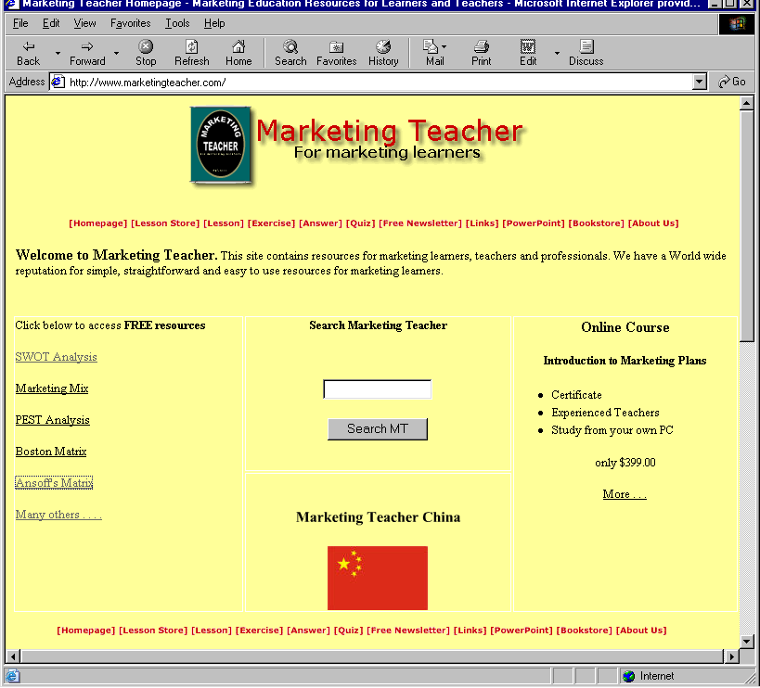

Figure 1. The Original, Western Marketing Teacher Website

Early in 2003, colleagues from the Business Management Group at King Alfred’s College of Higher Education in Winchester and University College Chichester began to plan a website to help students from the Greater China Region learn the basics of marketing using The Internet. For the purposes of this paper the Greater China Region (GCR) includes the People’s Republic of China (PRC) as well as its neighbouring nations. www.marketingteacher.com.cn was created to provide e-learning resources for learners, teachers and professionals in the Greater China Region. The project exploited the fact that one of our number was going to be teaching in Singapore during the Summer 2003 and that we had a working relationship with another Western educator working in the PRC.

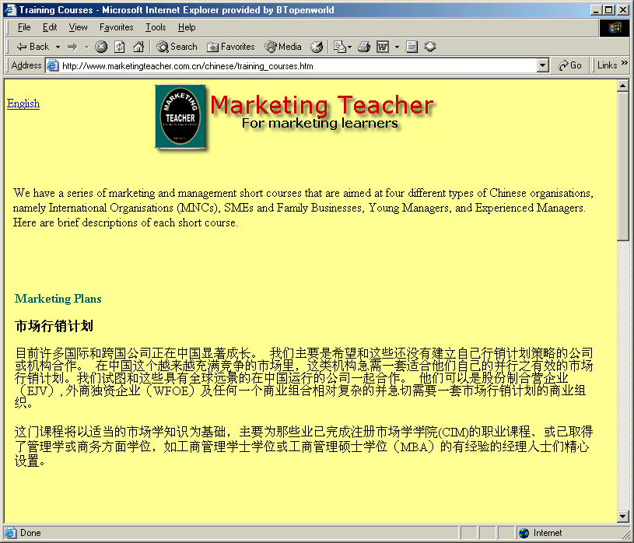

Figure 2. The Adapted Putonghua (Mandarin Chinese) Website

2. The context of online education in the People’s Republic of China.

China has 1.3 billion people and the second revolution, that of the market economy, is now nearly twenty years old. There are three main reasons why china will quickly develop online learning. Firstly there are as many companies in China as there are people living in New York, approximately 19 million. Secondly there is a dramatic need for growth since nearly 400 new cities, with the associated explosion in jobs, have been created over the last two decades. Finally the Chinese population has a bimodal distribution of wealth (Levy 2003). The Eastern provinces tend to be very wealthy whilst those in the West remain relatively poor. Pressure has been put on the Chinese government by the World Trade organisation (WTO) to resolve this inequality and a central strategy is learning. Such an approach is deemed to be appropriate to drive a shift from a manufacturing economy to one which has a more knowledge-based workforce.
Tang (2000) offered an overview of recent Internet development in the People’s Republic of China (PRC). The Chinese government has been committed to developing information technology research and development since the late 1980’s and demonstrated this by implementing its ‘High Tech Research and Development Programme’ containing four Golden Projects. The four Golden Projects were launched in the 1990’s: The Golden Bridge provided the information technology backbone, the Golden Duty aimed to connect financial and taxation organisations, the Golden Card’s goal was to allow the acceptance of credit/debit cards in stores and at ATM’s, and the Golden Trade was designed to assist Chinese businesses to trade in Chinese characters (language symbols) in global markets. In 2003 it remains difficult to see how successful the Golden Projects have been. For example, it is very difficult to arrange credit card transactions in Renminbi (RMB) over the Internet, something that Western e-commerce takes for granted. Credit card usage forms the basis of later discussion since Marketing Teacher does have a non-obligatory, chargeable online course. The Chinese Information Network (CNNIC) published survey results in 2000 that indicated that there were 3,500,000 computers with 8,900,000 users and 15,153 websites in the PRC. The PRC is a country with a population in excess of one billion and the future opportunities for e-learning are fantastic.

3. Research objectives

- To apply cultural models and frameworks to free e-Learning for the Greater China Region.
- To anticipate the challenges for free e-Learning for the Greater China Region.

4. Research methodology and limitations

The article was based upon two main sources of information. The sources were the current literature detailing models and frameworks for cultural analysis, and two structured interviews conducted by e-mail. The literature was reviewed relating to models and frameworks of business culture. The benefits of this approach are that there is an academically respected base of research that can be drawn upon to assist with cultural analysis. The business approach to cultural assessment does rely upon an accepted epistemology that links in with other areas of cultural knowledge. For example, antecedents such as values and beliefs, education, social hierarchy and many others have their basis in cultural studies. The two in-depth interviews were conducted via e-mail with two Western business teachers based in the Greater China Region, one in Singapore and one in the PRC. The survey was designed around the key headings the cultural framework described by Terpstra and Sarathy (2000). The key headings were Values and attitudes, education, social organisations, technology and material culture, law and politics, aesthetics, language, and religion. The respondents were asked to simply offer a summary of their experience of free online learning in the Greater China Region. The responses contributed towards the wider evaluation of the GCR’s culture based upon the Terpstra and Sarathy (2000) frameworks that appears later in this paper. The limitations of such a small were offset by the fact that deeper responses were generated. Access was unavailable to Chinese respondents that
had experience of business education in the GCR and that could confidently articulate responses in English. The researchers have very little knowledge of Putonghua and this is recognised a limitation, especially considering the cultural nature of this paper.

5. Selection of Appropriate Cultural Models

There are a number of models and frameworks that could be used to analyse the culture of the People’s Republic of China (PRC) to give an indication of the appropriateness of e-Learning strategies. Some are very detailed whilst others are straight-forward. The models and frameworks initially considered included those of Hawkins et al (1992), Terpstra and Sarathy (2000), Hofstede (1984, 1994, 1996), and Wills et al (1991). This list is by no means conclusive but gives an indication of the breadth of models and framework in the literature. The models of Hawkins et al (1992) and Terpstra and Sarathy (2000) are similar and contain some common antecedents such as values, education and learning, social status and organisation. Hawkins et al (1992) approaches culture from a consumer lifestyle perspective whilst Terpstra and Sarathy (2000) consider culture in its wider contexts. This means that the Terpstra and Sarathy (2000) cultural framework is much simpler and easier to apply. For these reasons Terpstra and Sarathy’s framework was preferred and implemented over the model of Hawkins et al. A more detailed audit of the Chinese website follows later using this framework.

The influential work of Hofstede (1984,1994,1996) on culture contains more than 11,600 questionnaires from more than 50 countries. The dimensions of culture are based around individualism/collectivism, power distance, masculinity/femininity and uncertainty avoidance. Unfortunately none of the original surveys focused upon the PRC. However parts of the Greater China Region, Singapore, Hong Kong (not part of the PRC until 1st July, 1997) and Taiwan, were included. All three score highly in power distance which indicates that people are unequal in terms of their physical and intellectual capacities, and this is especially high in Singapore. Uncertainty avoidance tended to be low in Singapore indicating an ability to handle uncertainty, moderate in Hong Kong and relatively high in Taiwan. These result are not surprising considering the political contexts of the region in the mid-1990’s. All three places score low on individualism which indicates collective cultures with tight integration. All three regions were similar in terms of masculinity/femininity with moderate scores. The Greater China Region is made up of diverse cultures and this should be taken into account when creating web content for learners. As educators we try to deal with learners as individuals but we need to appreciate the collective nature of culture in the Greater China Region. Perhaps as these regions adapt to the market revolution a more individualistic culture will emerge. Hofstede (1996) revealed an additional fifth dimension namely Confucian dynamism. Confucianism is a Chinese trait and its characteristics include a strong bias towards obedience, the importance of rank and hierarchies and the need for smooth social relations. The Chinese e-learner may feel that they are subservient to a teacher and this could prove problematic when no physical tutor exists. There could also be an indication that if problems exist that the learner may not contact the teacher/website to put things right. They could accept second rate materials or simply not revisit a website.

 | Dimensions
Country/region | Power distance | Uncertainty avoidance | Individualism | Masculinity
Singapore | 74 | 8 | 20 | 48
Hong Kong | 68 | 29 | 25 | 57
Taiwan | 58 | 69 | 17 | 45
Great Britain | 35 | 35 | 89 | 66
Overall Mean (from 52 countries) | 57 | 65 | 43 | 49
Standard deviation | 22 | 24 | 25 | 18

Figure 3. Values of Hofstede’s Cultural Dimensions for

52 Countries and Regions (Cited in Usunier 1996)

The dimensions of learning, or ‘diffusion,’ are used to consider a cross-cultural model that suggests a relationship between the high/low context of a culture and the rate at which new products are adapted (Wills et al 1991). Naturally products per se are not considered here but an educational service is. Therefore once an e-learning website meets the needs of its patrons one can expect it to diffuse into use relatively quickly i.e. the number of visitors and repeat visitors will increase relatively quickly.

Diffusion Rate
High context/Fast diffusion | High context/Slow diffusion
South East Asia  Japan | India  Asia
Low context/Fast diffusion | Low context/Slow Diffusion
Scandinavia  USA  Canada | UK  Eastern Europe

Figure 4. Interrelationship between context and culture: Wills et al (1991)

The cultural framework of Terpstra and Sarathy (2000) is used to consider the cultural context of the Marketing Teacher China free website. The key areas from the framework provide the structure for the analysis. The detail was provided by the responses from the two business teachers interviewed and a summary of key parts of the literature relating to values and attitudes, education, social organisations, technology and material culture, law and politics, aesthetics, language and religion.

Language

Religion

Values and Attitudes

Aesthetics

Education

CULTURES

Law and Politics

Social Organisation

Technology and Material Culture

Figure 5. A Cultural Framework – Tersptra and Sarathy (2000).

5.1 Language

The national and official language of the People’s Republic of China (PRC) is Mandarin Chinese (Putonghua) with 1.3 billion speakers. There are a further 200 languages in use as well as a countless number of dialects. People from differing provinces often have trouble understanding each other. However the dialects do have a common written form and this would be a saving grace when it comes to communicating with the whole GCR.
Translation of the Marketing Teacher website is an important issue and indications show that direct word-for-word translations are not adequate. Therefore beware the pitfall of self-referencing. From a Western perspective it would be like a Chinese website being translated into English, and as one respondent commented ‘It would be very boring.’ Hedberg and Brown (2002) comment that grammar is context specific in Chinese languages so that the student builds up a picture of the meaning of symbols as the text is being read. Hence graphics and pop ups can distract the reader and confuse the context of the communication. So catchy homepages that are intended to grab the eye can also confuse the non-Western reader and therefore have the opposite effect.

5.2 Religion

Taosim, Confucianism and Buddhism are the main religions. Care should be taken to make sure that religious beliefs are not contravened. However there may be a benefit in recognising the behaviour of Chinese e-Learners. For example, one respondent pointed out that by recognising a particular religious event or festival a website could earn favour and respect.

5.3 Values and attitudes

Chinese culture is influenced by the philosophical principles of key thinkers. Despite the ideological changes encountered during the Cultural Revolution and more recent market orientation, Confucianism still has a strong cultural impact upon Chinese society (Chan 1999). The culture in China strongly respects a good education and degrees and diplomas enhance a virtuous education (Oh 1991). The Chinese have a value orientation (Zhu and He 2002). Communism, materialism and Post-materialism are the three competing value orientations. The communist values see a selfless dedication to the well-being of society and mankind. The materialism values see the pursuit of immediate rewards and physical happiness. The post-materialism values see a way of life where the importance of material rewards is downplayed and there is an emphasis upon harmony between people and nature ( Inglehart, 1979). To understand the place of education in the GRC one need only to look at the expansion of education in the GCR and the increasing number of Chinese learners gaining Western qualifications. Whichever value the student subscribes to, education is highly regarded.

5.4 Aesthetics

There are a series of cross-cultural differences between Western designed websites and Chinese developed sites (Hedberg and Brown 2002). The results of their study into visual media and cross cultural meaning holds some interesting results for websites that undergo a straight translation from English into Putonghua. For example the left edge of the page may not be the point where the student begins to read. The aesthetics of Chinese art may hold the key to web design that suits Chinese learners. The Chinese are keen gamblers and game players. Games tend to be rich in colour and appear very complicated to the Western eye, and this is reflected in the popularity of Internet gaming. The cultural understanding of colour and images could also lead to confusion in communication. For example parts of Chinese culture see people marrying in black and being buried in white. Logos and symbols associated in marketing may not carry the same impact to Chinese learners as they do with their Western counterparts. According to the Chinese Peoples Daily top Chinese brands include Hongtashan (cigarettes), Haier (household appliances) and Wuliangye (liquor).Chinese Branding and images need to be considered when constructing case studies or using examples.

5.5 Law and Politics

The National People’s Congress is the highest organ of state power in the PRC. The Government is controlling and this makes commerce very different to that in Western Culture. The recent problems encountered during the SARS virus outbreak may make the Chinese government less prone to holding back information that is in the public interest. Copyright remains a huge grey area. This means that website content could be copied or reproduced without permission. Censorship still exists if one wishes to publish an educational text in China.

5.6 Technology and material cultures

Filtering is a problem for Western websites. Effectively the Chinese government censors websites by blocking access from China. The Chinese government maintains an active interest in preventing users from viewing certain web content. It has managed to configure overlapping nationwide systems to effectively block such content from users who do not regularly seek to circumvent such blocking. Such blocking systems are becoming more refined (Zittrain and Edelman 2003). Blocked sites tend to fall into one of a number of categories including democracy, health, news, government, religion, Taiwan, Tibet, entertainment and education. Indeed both the Western and GCR Marketing Teacher websites suffer from filtering. They share this disability with MIT, Learning Channel as well as almost 700 sites list in Yahoo’s education directories (Zittrain and Edelman 2003). The Chinese government does not co-operate on the issue of filtering and this makes it difficult to accurately represent the extent of this problem. Until its extent is understood, strategies for overcoming the problem cannot work. This is a huge problem for providers of free or chargeable content. One could invest time and effort in created online materials and promoting their existence only to find that your site has been filtered and that no right of appeal exists.

5.7 Education

A simple text translation into Mandarin has a series of problems. It should be appreciated that learning is an active process and teaching materials should be variegated (Liu, Lin and Wang 2002). The activity associated with online learning is seen as a clear advantage. It is the critical engagement with the World that ensures that learning takes place (Dewey 1916). The system of education in the PRC is demanding and often begins at a young age. Learning Putonghua demands a good deal of effort as well as time consuming rote learning. Chinese culture is collectivist and often depends upon informal chains of communication. Therefore open discussion albeit in forums or web casts could see an infringement of cultural values (Can 1999). Western educators need to be sympathetic to the successful teaching strategies used by Chinese teachers, and embed them into e-Learning projects. Levy (2003) explains that most learning in China takes place in classrooms. Even where technology such as television or software is used it tends to be heavily instructor lead.

5.8 Social organisation

Liu, Lin and Wang (2000) advocate that the individual learning styles and preferences of e-learners need to be taken into account since a simple text translation may suit some learners whilst a multimedia approach is beneficial to others. Indeed it is possible to take a deeper look into the learning styles of Chinese students. Confucian philosophy has a role in shaping Chinese thinking and learning styles (Chan 1999). So there is an opportunity to conduct leaning styles surveys (Kolb 1984, Mezirow 1991). This may give an indication of the preferred learning environment of the Chinese e-learner. Then web content can be developed to suit the preferences of a number of individuals. There is a need for further research into the learning styles of e-learners from the Greater China Region.

6. Conclusions

Based upon this cultural analysis, there are a series of drivers that will be taken into account as www.marketingteacher.com.cn is developed for the Greater China Region. The challenges for free e-learning are:

- The Greater China Region is made up of diverse cultures and this should be taken into account when creating web content for e-learners.

- Once an e-learning website meets the needs of its patrons one can expect it to diffuse into use relatively quickly.

- The Chinese e-learner may feel that they are subservient to a teacher and this could prove problematic when no physical tutor exists.

- Indications show that direct word-for-word translations are not adequate.

- Care should be taken to make sure that religious beliefs are not contravened.

- Whichever value the student subscribes to, education is highly regarded.

- Chinese branding and images need to be considered when constructing case studies or using examples.

- The PRC Government is still controlling. Copyright remains a huge grey area. This means that website content could be copied or reproduced without permission.

- You could invest time and effort in creating online materials and promoting their existence only to find that your website has been filtered and that no right of appeal exists.

Although this paper considered free e-learning for the Greater China Region, it holds some guidance for e-learning for the region in a wider context. Western educators need to be sympathetic to the successful teaching strategies used by Chinese teachers and embed them into e-learning projects. As educators we are all too aware that individual learners have preferred learning styles, differing educational experiences as well as other individual needs. However this issue multiplies when one has to consider the impact that an e-learning device such as a website has when it touches other cultures. The impact upon content could be tremendous. From our Western perspective we may naively believe that all we need to do to convert a successful Western website into a successful Chinese website is simply to get someone to do a direct translation. This is not the case. As educators our own skills sets need to be altered. Many educators have developed skills associated with building or maintaining websites. However these skills need to be developed to appreciate the local needs of e-learners in the cultures of the Greater China Region.

References

Chan, S. (1999), ‘The Chinese learner – a question of style,’ Education and Training, Vol 41 No. 6/7, pp. 294-304.

Dewey, J. (1916), Democracy and Education, MacMillan, New York, NY.

Doole, I and Lowe, R. (2001), ‘International Marketing Strategy,’ Thomson Learning, 3rd Edn.

Hofstede, G. (1984) Culture’s consequences: international in work-related values, Sage.

Hofstede, G (1994) ‘The business of international business culture,’ International Business Review, 3 (1).

Hofstede, G (1996) ‘Cultures and organisations: software of the mind,’ McGraw-Hill.

Inglehart, R. (1979) , ‘Value priorities and socio-economic change,’ Cited in
Zhu, J.J.H., and He, Z. (2002), ‘Information accessibility, user sophistication, and source credibility: the impact of the Internet on value orientations in mainland China,’ The journal of computer-Mediated Communication, Vol. 7 (2).

Kolb, D.A. (1984) Experiential Learning: Experience as the source of learning and development. New Jersey: Prentice Hall.

Levy, J. (2003) ‘The Next china Revolution’ Training and Development, Vol 57 No 5, pp. 58 – 64.

Liu, L., Fuzong, L and Xue, W.(2003), ‘Education practice and analysing behaviour in a web-based learning environment: and exploratory study from China,’ Online Information Review, Vol. 27 No. 2, pp. 110-119.

Marketing Teacher China Homepage http://www.marketingteacher.com.cn (accessed 1st September 2003)

Marketing Teacher Homepage http://www.marketingteacher.com (accessed 1st September 2003)

Mezirow, J. (1991) Transformational Dimensions of Adult Learning, Jossey-Bass.

Oh, T.K. (1991), ‘Understanding managerial values and behaviour among the gang of four: South Korea, Taiwan, Singapore and Hong Kong,’ Journal of Management Development, vol 10 No. 2, pp. 46-56.

Tang, J. (2000), ‘Recent Internet Developments in the People’s Republic of China: an overview,’ Online Information Review, Vol 24 No. 4, pp. 316-321.

Tan, Z.X. (2000), ‘’Information and Telecommunications in china on the Internet,’ http://web.syr.edu/~ztan/news.html

Tan, Z.X., Foster, W. and Goodman, S. (1999), ‘China’s state co-ordinated Internet infrastructure,’ Communications of the ACM, Vol. 6, pp. 44-52.

Tang, J. (1998). ‘The Four Golden Project in China: the pathway to electronic commerce,’ Information Development, Vol. 14 No 3, pp. 133-5.

Terpstra , V. and Sarathy, R. (2000) ‘International Marketing’ Dryden Press, 8th Edn.

The Chinese People’s Daily Online. - http://english.peopledaily.com.cn/200112/18/eng20011218_86963.shtml

Usunier, J.C. (1996), Marketing Across Cultures, Prentice-Hall, Hemel Hempstead, pp. 78-79.

Wills, J.I., Samli, A.C. And Jacobs, L. (1991) Developing global products and marketing strategies; a construct and research agenda,’ Journal of the Academy of Marketing Science 19, (Winter) 1-10.

Zhu, J.J.H., and He, Z. (2002), ‘Information accessibility, user sophistication, and source credibility: the impact of the Internet on value orientations in mainland China,’ The journal of computer-Mediated Communication, Vol. 7 (2).

