The research indicating the reluctance to vote in UK General Elections is repeated and underpinned through the turnout in the European Parliament election of 1994 (Table 2)
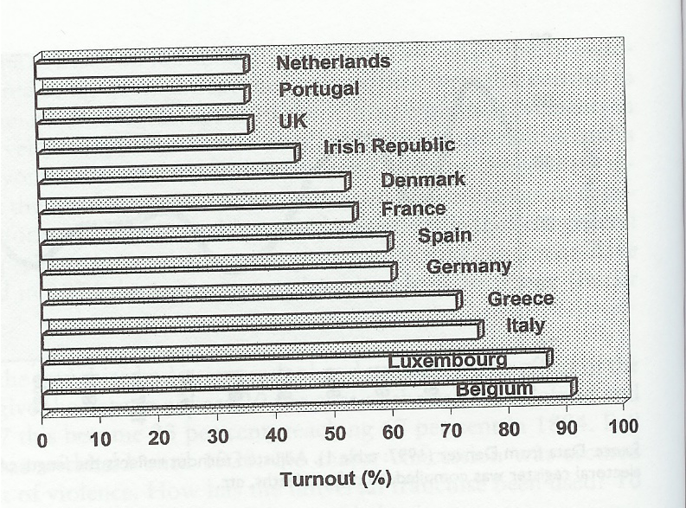
Table 2: National turnouts in 1994 European Parliament Elections (Social Trends (1997:Table 13:28) cited Kingdom 2001 p.238)

Studies by Butler and Stokes (1969, cited Kingdom 2001 p.237) have shown that most people are stable voters supported by a volatile though increasing minority who are described as floating voters. This research continues to highlight that since the 1970s there has been an increase in net volatility that has resulted in increased support for centre of the road, nationalist and other specialist parties for example Green Peace and Respect (Table 3).
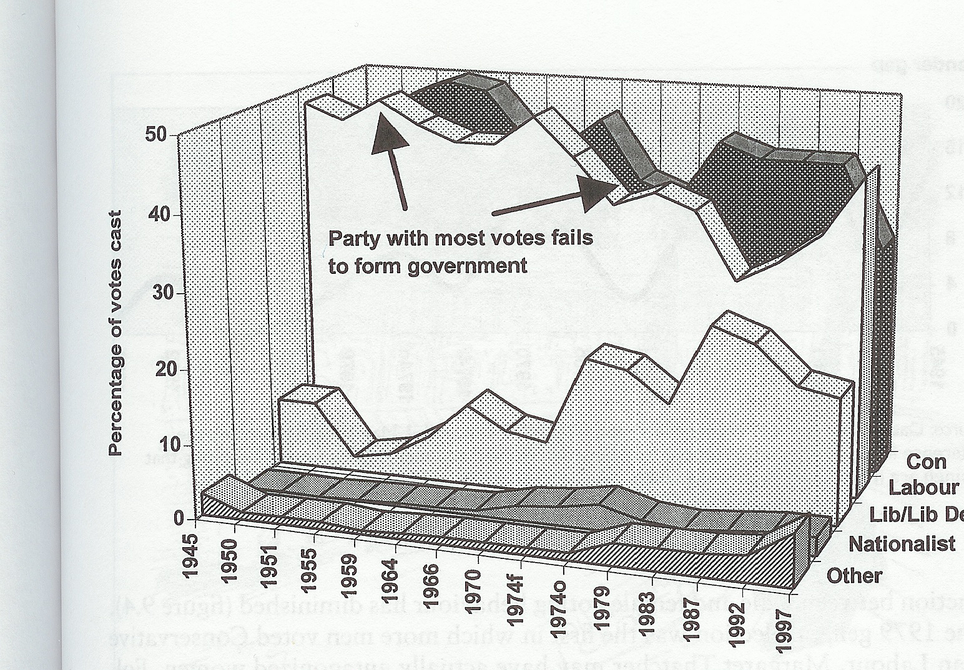
Table 3: Post War voting trends (Butler and Stokes (1994:p. 216-219) cited Kingdom 2001 p.239)

Kingdom (2001) goes onto identify the reasons why people repeatedly support the same party. The reasons given are as follows:

Loyalty – Loyalty towards a political party inspires the party identification voting model. It is estimated that up to 80% of voters identify with a particular party. In the decades of high turnout, the 50s and the 60s up to 90% of voters stayed loyal to their party. This view on loyalty is supported by Butler (1995, cited Kingdom 2001 p.238) in his research stating that most citizens remain faithful to their selected party and always vote as before and usually as their parents voted before them.

Ideology – Crewe (1993, cited Kingdom 2001 p.239) stated that the main parties are usually closer to the views of their middle-class supporters with the exception in recent times being the Conservative party under Thatcher. The current battle for middle Britain in the 2005 election appears to support the research by Crewe.
Gender – Kingdom (2001) suggests that working-class women are more likely to vote Conservative due to their lack of involvement in large heavy industry and the social environment of working clubs, pubs and sport. However an alternative view is put forward by Hills and Hence Norris (1981 and 1993, cited Kingdom 2001 p.239) when they suggested that as women live longer their views change as they experienced more of life. Kingdom (2001) went on to suggest that the differences between the voting patterns of men and women were due to the different social circles that they occupy and not as a result of gender, this view is supported by recent research by the Electoral Commission (2004) that stated there is not a gender gap in voter turnout..
Age – The younger voter of the day are more likely to vote in accordance with the issues of the day and support the more radical policies, for example for and against fox hunting and the protests against the Vietnam War and the recent conflicts in the Middle East. Research carried out by the Charter 88 (2002, cited Howland and Bethell 2002 p.16) revealed that over 91% of young people would participate in politics if the parties addressed issues that mattered to them, this research is supported by the demonstrations against University tuition fees in 2003.
Race – Research by Todd and Butcher (1982, cited Kingdom 2001 p.241) shows that black people are less inclined to register to vote than whites, however those of Asian descent are more likely to vote than their white counterparts. Asian and black vote in 1992 72% and 90% in favour of Labour. Politicians are increasingly looking for the ethic vote and appear to be focusing on race relations and immigration issue.

Research by Bromley et aI (2001) investigated the potential involvement of voters in direct action over the period of 1983-2000 (Table 4) if the government where to introduce a law that they felt was unjust. The outcome indicated that the willingness to take direct action remains stable with 38% of individuals prepared to participate in more than 3 events.

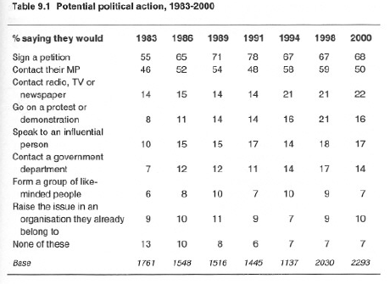
Table 4: Potential Political Action 1983-2000 (Bromley et al, 2001)

Table 5 highlights those voters that had participated in some form of direct action over the period 1986-2000 and it would appear that this has also remained stable. Further research by Bromley et al (2001) states that 87% of those who had taken direct action also voted in the 1997 General Election compared to 71% of those that did not take direct action. A similar comparison was carried out after the 1999 European Election with 50% and 30% respectively. This would suggest that over this period there was not a move away from the ballot box to direct action, indeed it would suggest that those more likely to take action are also likely to vote. Since the last General Election we have seen direct action taken place by those opposed to the second Gulf War, the fuel protests and those against the banning of fox hunting. If the statistic of 80% of those taken direct action also vote it is anticipated that this will result in an increased turnout at the election in May 2005.
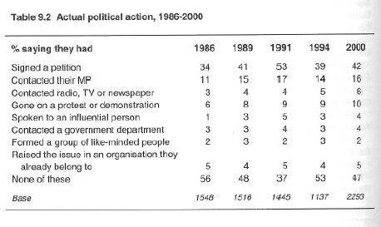
Table 5: Actual Political Action 1983-2000 (Bromley et al, 2001)

Further research by Bromley et al (2001) looked at the level of confidence in the political system by the electorate (Table 6).

The electorate have during the period 1974 – 2000 (Table 6) shown low levels of trust in the of government of the day and politicians. This view has remained fairly static over time. This view has been further underpinned by the common belief reported in most newspapers that readers believed that the Prime Minister lied over the reasons why the Country went to war with Iraq. However there has been an increase in the view that politicians will put the needs of their party above the needs of the government. This view of distrust has not been extended to other forms of authority, for example trust in the police force has risen. This indicates that we have lost confidence in the workings of our representative democracy rather in those that lead us.
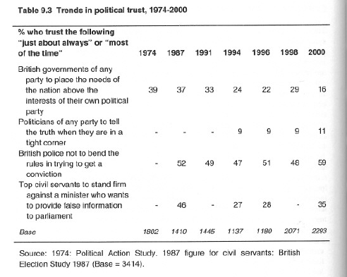
Table 6: Trends in Political Trust 1974-2000 (Bromley et al, 2001)

Bromley et al (2001) continued to report that confidence in the political system fell in the 90’s with a slight increase after the 1997 General Election when New Labour came to power replacing the perceived sleaze ridden Government of John Major (BBC Vote 2001. Over the same period similar results were found in the confidence levels of individuals in their ability to clearly express their needs and demands. In short these results show confidence in voters to be expressive but less confidence in the system to deal with their demands.

Kilbrandon Commission (2001, cited Park et al 2001 p.199) asked in the early 70’s the following questions which have been repeatedly asked since:

Which of these statements best describes your opinion on the present system of governing Britain?

- It works extremely well and could not be improved?
- It could be improved in small ways but mainly works well?
- It could be improved quite a lot?
- It needs a great deal of improvement?

Responses to these questions have confirmed previous research. 78% of responses showed dissatisfaction in the system overall although this was reduced after the 1997 election to a level that was found when the questions where first posed in 1973 but has since returned to previous levels. This would indicate that the reforms introduced by Labour after the 1997 election to encourage people to be more involved in how they are governed has had little or no impact. Further research by Kilbrandon (2001) shows that the levels of trust in the sleaze ridden government of John Major was low in die hard labour voters, high in Tory voters and low in the none political party group, recent research has shown that there has been a reversal between the Labour and Tory voters, but the confidence level in the none party group has remained low (Table7).

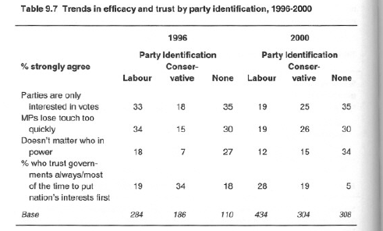
Table 7: Trends in efficacy and trust by party identification, 1996-2000 (Bromley et al, 2001)

Initial research would indicate that there appears to be no definitive evidence to suggest that lack of trust and confidence in the Government is the reason for the decline in participation in the political process. Although recent research would support the view that lack of trust and by party groups does encourage voter apathy and it further indicates that continued non participation does lead to increasing levels of apathy in the administrative process. Research has shown that those individuals who opt out of the electoral process are not more likely to participate in other forms of action.

As we become better educated there is a greater expectation of what we want from our politicians. The smaller world and the impact of events elsewhere coupled with the speed of communications make it more difficult for politicians and Governments to have the same level of power and opportunity act in isolation that they once had. This combined with greater expectations makes the politician appear to be less effective. This is called the “relative capacity” argument. This argument can be measured by looking at what qualities we expect to see in our Member of Parliament (MP). The results of the research carried out by Bromley et al (2001) have changed very little over time with clear emphasis on the expectation that our MPs have an understanding of the local area and are independent minded (Table 8). Recent research carried out by the Electoral Commission (2004) has shown that the overall satisfaction in the way that local MPs do their jobs as being only 41%. More of a concern was the result that 47% did not give an opinion, possibly highlighting the apathy in politicians as a whole.

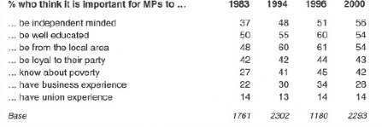
Table 8: % who think it is important for MPS to…1983-2000 (Bromley et al, 2001)

However expectations in the key areas of health, the elderly, economy and employment (Table 9) have increased at a time when our expectations in those we expect to deliver has decreased. In tandem with this greater expectation there is also a realisation that it is getting more difficult to deliver what we want in those key areas.
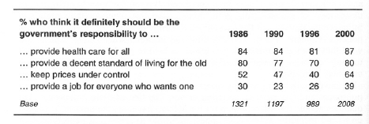
Table 9: % who think it definitely should be the Government’s responsibility (Bromley et al, 2001)

The way that people vote is not only determined by their background, social class and the influence of parents and colleagues, it is determined by the public face of elections and the individuals’ involved. This part of the report will focus on the psephlogical factors that make individuals express their views through the ballot box.

Information provided by Timeweb (2001) shows the turnout at General Elections from the 1964 election to the 2001 election Table 10. It clearly shows that prior to 1992 the turnout remained fairly static and from that date it went into sharp decline resulting in the record low in recant elections of 59.38% in the 2001 General Election.

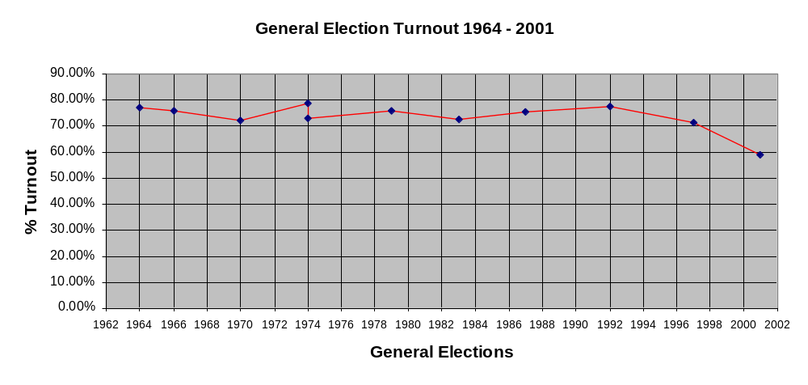
Table 10: Derived from information provided by Timeweb 2001.

The 1964 election (BBC 1997)

The 1964 election was very much a two party fight with the Conservative Party who had been in power for 13 years and the Labour Party. The buoyant economy that led to Macmillan's previous election was faltering by 1961 and in 1964 announced that the balance of payments figures showing a £73m deficit. The Government of the day ran into further problems when Britain's application to join the Common Market was rejected by the French. Scandal added to the Government's problems when John Profumo was forced to resign after he admitted lying to Parliament over his involvement with a call girl. The Government looked tired, embattled and increasingly out of step with the public mood. Prior to the election Macmillian resigned due to ill health and was replaced by Sir Alec Douglas-Home who was viewed as being distant and removed from the electorate. In opposition the Labour party had recently appointed Harold Wilson to be their leader, a pragmatic, charismatic leader who was to prove too much for Douglas-Home.

The Labour party manifesto – A new Britain - campaigned on economic planning, growth and scientific changes were given prominence. New ministries for Wales, overseas development, technology and economic affairs were promised. However the main strength of the Labour thrust for power was in the new leader Harold Wilson.

The Liberals' campaign theme, laid out in their manifesto, Think for Yourself - Vote Liberal, was a federal Britain in a federal Europe. During the early 1960s the Liberals had experienced a surge of support as many voters grew tired of the Conservatives and were reluctant to turn to Labour. This election would see them field candidates in every constituency and campaign with real vigour for the first time since the general election of 1950.

This was the first election to make extensive use of the television to promote their manifestos. The television was used sparingly by Douglas-Home who disliked this medium. The decision not to use the television may have contributed to the view that Douglas-Home was distant and removed from the electorate

The electorate tired of Conservative rule mandated the Labour party with control of the country with the smallest of majorities since 1847.

