Word Count:

University College Winchester

School of Social Sciences

BA (Hons) Degree in Business Management
with Public Service Management

Final Year Project 2004-05

Voter Apathy the Background and the Solution

By

David Jarvie Harris

Supervisor: Professor Mike Hart

3rd May 2005

LIST OF TABLES

Table Page

1. Overall turnouts in post war General Elections
(Denver (1997:Table 1) cited Kingdom 2001 p.237) 10

2. National turnouts in 1994 European Parliament Elections
(Social Trends (1997:Table 13:28) cited Kingdom 2001 p.238) 10

3. Post War voting trends
(Butler and Stokes (1994:p. 216-219) cited Kingdom 2001 p.239) 11

4. Potential Political Action 1983-2000 (Bromley et al, 2001) 13

5. Actual Political Action 1986-2000 (Bromley et al, 2001) 14

6. Trends in Political Trust 1974-2000 (Bromley et al, 2001) 15

7. Trends in efficacy and trust by party identification,
1996-2000 (Bromley et al, 2001) 16

8. % Who think it is important for MPS to…1983-2000
(Bromley et al, 2001) 17

9. % who think it definitely should be the Government’s
responsibility (Bromley et al, 2001) 18

10. General Election Turnout 1964 to 2001 (Timeweb 2001) 19

11. Simulation of the 1997 General Election
under different electoral systems (Dunleavy et al, 1997b) 37

List of Figures

Figure Page

1. Numerical coefficients, How Children vote
(Dennis and McCrone 1964) 4

- Numerical coefficients, How Children vote – partial effects
(Dennis and McCrone 1964) 5

3. Individual and cumulating effects on the probability
of voting Labour due to various working class
characteristics, from regression analysis of major party voters
(Dennis and McCrone 1964) 6

List of Pictures

Picture Page

1. Harold’s a Hit
(BBC 1997) 21
Abstract

The aim of this study is to evaluate the attempts by the Government to encourage the electorate to engage in the political process and to identify the reasons for voter apathy.

The report initially researched the social factors that have an affect on the way that we vote from the 1960’s to date highlighting the relevance in today’s modern world. The second area of research surrounded the way that the electorate perceive politicians, the legislative process and the climate in which elections take place. To conclude the report looked at the solutions suggested to improve turnout at elections and increase political engagement.

This study found that the way that we vote is influenced by the manner in which we are reared and the life experiences that we have. The traditional voting patterns of following the example of our parents have changed as a result of a transient work force that is better educated and more travelled.

The Government have made a number of attempts to improve turnout, most notably postal voting. Postal voting has increased the number of votes cast but is seen by many to be open to abuse. The electorate is prepared when necessary to take to the streets to make their feelings known suggesting that for them to be engaged in the process they need to have issues that are relevant to them.

Contents

Chapter Page

Title Page i

List of Tables ii

List of Figures iii

List of Pictures iv

Abstract v

Chapter 1: Introduction xx

Chapter 2: Literature Review xx

Chapter 3: Discussion xx

Chapter 4: Conclusion xx

List of References xx
Chapter 1
Introduction

Why and How we vote?
Voting is the most important way to make your voice heard on the issues that concern you and making your elected representatives accountable.
Decisions are made on your behalf every day, ranging from what is happening in local schools and what recreational facilities you have, to national issues like healthcare and education, to global issues like defence and the environment.
In many countries around the world, including the UK, people have fought to gain the right to vote. The right for women to vote on equal terms with men in the UK was still being debated only 70 years ago. But having the right to vote is not enough. A strong and stable democracy also relies on people exercising that right.
Voting is central to the way in which our democracy works. Research carried out by the Electoral Commission (2001) has shown that in the last UK general election in 2001 turnout was down from 71.4% to 59.4%. This represented fewer than six out of every ten eligible voters across the UK decided to take part in choosing the country's leaders, decision makers and who would govern the country for the next four to five years. The apparently accelerating trend away from participation in the institutions of democracy contrasts with what seems to be a growing tendency for people to make their voice heard through a variety of forms of direct action such as the anti-war demonstrations against the second Gulf War and the more recent Pro-Hunting rallies, rather than through the ballot box.
Detailed research discussed later in this project will show that people do not vote for a number of reasons - including lack of information, lack of trust in politicians and the political process, issues of the day, age and inconvenience.
This project will look at the possible reasons for the decline in electoral turnout, the increased involvement in direct action and highlight the possible solutions to encourage greater involvement in the electoral process by the electorate since the early 60’s to the current date.

The historical study of British Electoral behaviour over the past 25 years has two complementary strands:

Firstly – Behavioural – focusing on the private face of election campaigns and results by unravelling the ways that individual voters make their decision by looking at social class, effects of upbringing, education and other characteristics that differ from voter to voter. .

Secondly – Psephological – focusing on the public face of election campaigns and their results by:

- Documenting the context within which an election took place.
- The events leading up to it and the manoeuvring of major political actors.
- The issues that made the news and the debates that took place.
- The outcome and its interpretation in terms of the other important themes.

The project will then turn to the possible solutions to voter apathy and how the Government are attempting to reengage the electorate in the democratic process and in turn have a Government that reflects the wishes of the electorate.

Chapter 2
Literature Review

Studies by Butler and Stokes (1974, cited by Franklin 1985 p. 8) state that the social class that you are born into and the social path that you take determine the way that you vote. They go on to say that this continues through to adult life as you spend time with work colleagues and friends. As you pass through different stages and experiences in life your individual needs have an effect on how and if you vote.

Early political awareness begins in the home with your parents, friends and family, their background and their environment being a major factor. Studies by Dennis and Crone (1964, cited by Franklin 1985 p.9) have shown that 80% of British children are politically aware by the age 10. That initial awareness being determined by the views of their parents and the social class that they are part of (Figure 1). As can be seen by figure 1 approximately one third of children followed the lead of their parents and voted for the party they voted for.

Parents Labour Supporters - - - - - 34% - - - - - Child initially voted Labour
Parents Working Class - - - - - - - - 30% - - - - - Child initially voted Labour
Figure 1: Numerical coefficients, How Children vote
(Dennis and McCrone 1964)

The data presented in figure 1 if taking in isolation can be misleading as it suggests that both those areas are independent of each other when in fact it is accepted that a large number of working class people vote for Labour. Figure 2 takes the comparison further and links working class and Labour supporters.

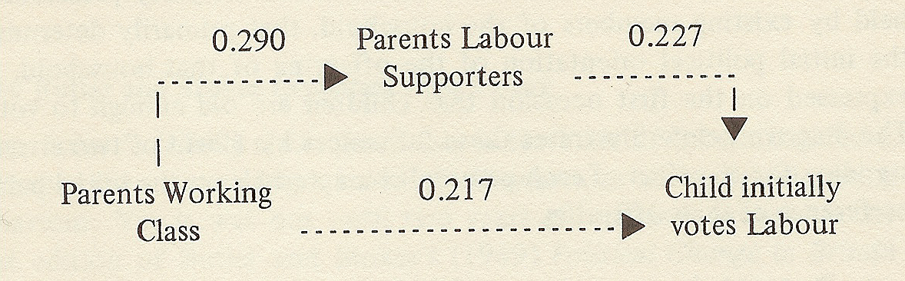

Figure 2: Numerical coefficients, How Children vote – partial effects
(Dennis and McCrone 1964). Please note that .227 should read .277, error is in text.

In Figure 2 the results are more accurate as it combines factors, class and support for the Labour Party. It shows that the chances of a voter from this background are 50% more likely to vote labour (0.277 and 0.217 added and rounded up). At this point the research highlights the affect parents have on the way that their children vote. The research at this sage does not go on indicate when children change from being directly influenced by parents to being independent in their voting.

Figure 3 takes the research further and aggregates a number of additional social factors that have an affect on the chances of individuals voting Labour in the 1964 General Election in order of importance. The first predictor is on the right with additional social issues being added as the chances of voting Labour increases from left to right ending with all the issues being grouped in the final left hand column.

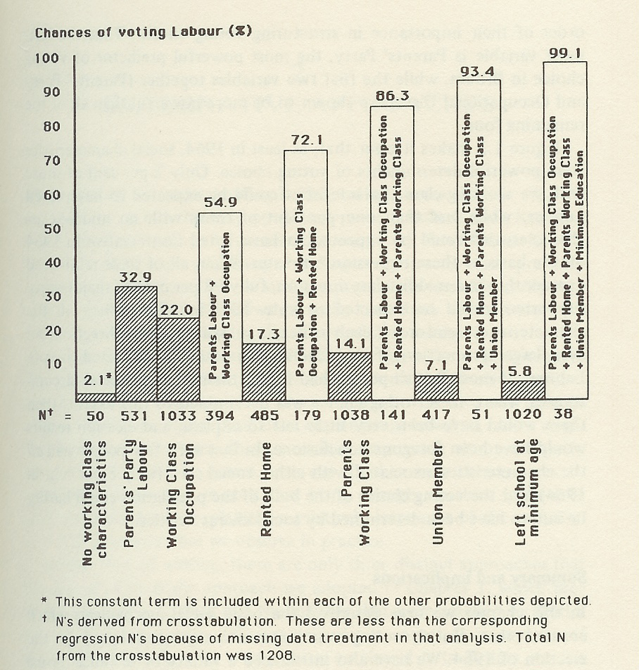

Figure 3: Individual and cumulating effects on the probability of voting Labour due to various working class characteristics, from regression analysis of major party voters: (Dennis and McCrone 1964).

However it should be noted that the research carried out by Dennis and McCrone (1964) that as the additional factors are added the numbers affected reduce resulting in only 8% of the voting population had all characteristics identified in the right hand column highlighting that many social factors have an affect on how we vote.

Studies by Forman and Baldwin (1996) have shown that since World War 2 (WW2) voting behaviour has in general been split between two main parties, the Conservative Party and the Labour Party. Since WW2 approx 6.5 to 7.5 million voters have remained loyal to both of the main parties, Labour and Conservative. Since mid-70’s the Liberal party became the 3rd party with a loyal following although the election arena has been further complicated with the introduction of nationalist parties such as SNP and Plaid Cymru.

Further research by Forman and Baldwin (1996) has highlighted that the number of floaters and abstainers has varied in numbers at each election since war. This group can have an important affect on the outcome of elections and over the period 1959 - 1979 half of electorate changed its voting behaviour at least once. Floating voters are particularly important to smaller parties who benefit from desertions from the main parties. Abstainers account for between 16-28% of the total electorate at each election since the last war.

The following statement and research carried out by Forman and Baldwin (1996) indicates the importance of social class in relation to how we vote when they quoted, Peter Pulzer (1967) who “observed that class is the basis of British party politics; all else is embellishment and detail”. The view expressed by Peter Pulzer (1967) is supported by Jean Blondel (cited Forman and Baldwin 1996) who wrote that, “the simple division between working and middle class…contributes to the clearest cleavage in British political attitudes and voting behaviour”. However as can be seen by the earlier research carried out by Dennis and McCrone many factors affect the way we vote and the chances of them all falling into place are slim. Due to better education and a greater understanding of what we the electorate want and the changing face of the political parties has increased the number of floating voters so these statements although accurate at he time they were expressed do not explain changes since the 90’s were individuals appear to be prepared to take direct action and vote in response to specific issues.

Forman and Baldwin (1996) go on to say that since WW 2 two thirds of middle class and one third of working class vote Tory and that it should be noted that the working class Tories vote is very unpredictable, the current election and the continued reference in news reports on how middle Britain will vote supports their findings. It would appear the working middle class group vote depending on their views or needs at the time of the election. In the last 20 or so years this has possibly been linked to the huge number of owner occupiers that emerged since the owner occupier right to buy legislation of the 80’s thus splitting the traditional working class group. The minor party support gain votes not linked to class but to feelings and beliefs, for example the environment with Green Peace and Britain out of the European Union with the United Kingdom Independence Party.

Further research by Forman and Baldwin (1996) has highlighted the following factors in how we vote:

Gender and age differences in voting: Prior to the mid 1960’s the male vote was mainly in favour of Labour with females more in favour of the Conservatives. However since the emergence of the Liberal Democrats the female vote has been split. Research by the Electoral Commission indicates that the female vote increases by 4% when a female candidate is standing. Further research carried out by the Electoral Commission (2004) indicates that there is not a gender gap when it comes to elections. Younger voters keen on Labour possibly as a direct link to the influence of our parents, middle age to early old age keen on Tories young middle age and over 65`s more fluid in their voting behaviour. The battle for the older voter is a current issue, the increasing cost of Council Tax is a burning issue for pensioners and the parties are vying for their support, for example with the Conservative party offering £500.00 to each household occupied by a pensioner.

Geographic and Sociological voting: Scotland, North East and Wales traditionally had heavy industry with strong union influences with the result in large support for the Labour party. The Midlands and South of England have tended to vote Tory. Liberal party have traditionally done well in the rural areas of the South West, East Anglia and the Highlands. The research carried out by Forman and Baldwin (1996) indicates that in the working class with the traditional working class values reflecting Union views members vote Labour and the owner occupiers who maybe self employed, are not union members and living in the South East supporting other parties.

Political Inheritance: This is voting as our parents and their parents did. Seen more in the traditional working class and high rich class. Also split in areas i.e. the North East, South Wales (miners), Scotland and the South East. This is not as strong as before as voters and the workforce move around more and are better educated.

Self-interest: The current situation of the pensioners voting for the party that is going to make them better off. This is also the individual who votes for a specific party for specific reasons and beliefs for example voting for a party who support fox hunting in opposition to the Labour Party who have introduced legislation banning fox hunting or as a reaction to the recent conflict in the Middle East. Labour have traditionally looked after the poor and the Conservatives have been the domain of the well educated and the affluent.

Government performance: This has the greatest effect on the floating voters who decide on the issues of the day for direction in their voting behaviour.

Research by Kingdom (2001) charts the evolution of the electoral system from the humble beginning with an electorate of a mere 400,000 of the population through the 1832 Reform Act that increased the electoral pool to 700,000 whose right to vote rested on the value of their property onto the failed “Chartism” movement, the introduction of the Representation of the People Act of 1867 which gave the right to vote to all males resulting in 2.5 million voters. This evolution continued with the suffragette movement gaining the right to vote for women over the age of thirty in the Representation of the People Act of 1918 and full age equality with males in the 1928 Equal Franchise Act. The right to vote at 18 years old was introduced in the Reform Act of 1969. Kingdom (2001) states that it is a democratic right to abstain from casting a vote, however there is evidence that suggests that voluntary abstainers come from most deprived sections of society, a marginalised category seeing politics as largely irrelevant, Johnston and Pattie (1997, cited Kingdom 2001 p.236). Kingdom (2001) goes on to state that individuals participate in elections for a number of reasons, such as, class solidarity, a herd instinct, a sense of civic duty or particularly among females a tribute to those who fought to gain them the right to vote.

However further research by Kingdom (2001) highlights the increasing trend not to vote with the trend not to vote reaching a post-war low at the
1997 General Election (Table 1).
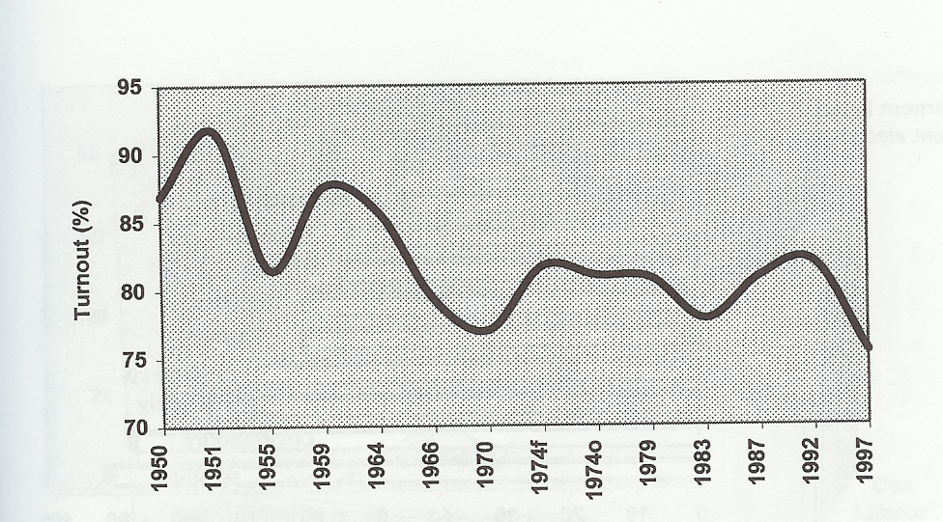
Table 1: Overall Turnout in post war General Elections (Denver (1997:Table 1) cited Kingdom 2001 p.237)

